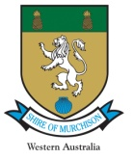

The Shire of Murchison invites nominations for an award of “Volunteer of the Year” to be awarded to a community member who has provided outstanding voluntary service to the community.

Nominations are to be forwarded to the Shire office either in person or by email to admin@murchison.wa.gov.au.

Nominations close at 4pm on 21st March 2019

Name of Nominated Volunteer

Date of Nomination

Reason for Nomination: (Please include details of the nature of volunteer work undertaken, the period the work was undertaken, and the reason for the nomination. Please attach any supporting documentation)

Name & signature of Proponent

Proponent Contact Details

The award will take the form of a Framed Certificate, signed by the Shire President.

